Glowtag FD-02 — The Data Crown: Spawn, Possession & Feedback
Owns where the Crown appears, what it is, and how the game communicates who has it.

Spawn decision
Random authored location, deliberately asymmetric, telegraphed. Not attached to a player at round start.
Option | Strength | Why not
Attached to a random player at start | Zero dead time, legible immediately | The first possession is given by a coin flip rather than earned, the recipient is instantly swarmed, and it wastes the strongest beat the mode has — the opening race — by resolving it before it starts
Random location, unconstrained | Everyone has agency | Can land inside geometry, or dead centre of the pack where everyone arrives at once and contact noise decides the round
Random authored, asymmetric, telegraphed | Agency, earned first possession, and a clear favourite plus clear chasers from the moment the beacon appears | Needs an authored candidate set and a selection pass. Small cost, and FD-06 already requires authored points for other reasons

The telegraph is the cheapest quality win available: it turns crown_spawn_delay from dead time into positioning time, so first possession is decided by driving rather than by who happened to be facing the right way.

Spawn selection
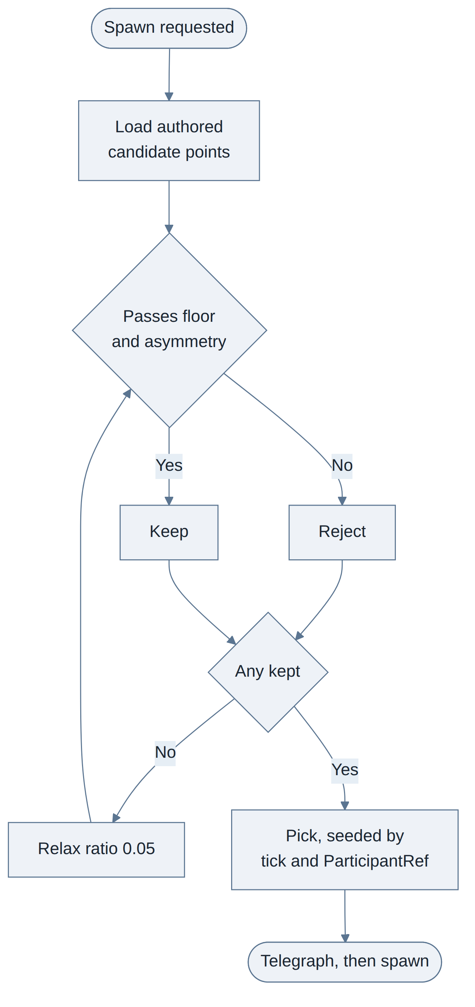
Rule | Detail
Candidates | Authored points, never arbitrary coordinates. Removes the inside-geometry case entirely
Asymmetry check | dist(nearest) <= spawn_asymmetry_ratio * dist(second-nearest). At 0.7, the closest player must be at least 30% closer than the next. This is the rule that guarantees a favourite exists
Floor check | dist(nearest) >= min_spawn_distance. Stops a free uncontested pickup
Participants | Bots count exactly as players do in every check here
At 5-6 participants | Checks consider only the two nearest. The rest are chasers by definition
At 2 participants | Reduces to exactly what it sounds like: one is nearer
No valid candidate | Relax the ratio in 0.05 steps until one passes. A slightly-too-fair spawn beats a missing Crown
Determinism | Selection is authority-side and the result replicates. No unseeded randomness — the foundation forbids it; use a deterministic function of tick and ParticipantRef, per FD-07

Mid-round respawn. The Crown exists unheld only at round start and after a holder disconnects. On a disconnect respawn, the same checks apply and candidates are additionally weighted toward the lowest-scoring player. This is never announced and never shown.

The Data Crown
A holographic cube of code glyphs suspended inside an open ring cage. On a scripting platform, the thing everyone is fighting over is the program.
State | Form
Unheld | Cube slowly rotating inside the ring cage, hovering about a metre up over a shadow decal, bobbing. The ring is the silhouette read at distance
Transition | On pickup the cage snaps open and reforms above the robot over ~0.3 s. This doubles as the steal beat — see FD-03
Held | The cage becomes a tilted ring orbiting above the robot, spinning faster, cube at its centre

Cost: two rigid meshes, one emissive material, code-driven rotation and orbit. No rig and no animator, which matches the team.
On making it read in daylight. Emissive alone does not survive sunlight. The Crown gets four things together: a hard ring silhouette, high saturation against a desaturated arena palette, constant motion, and a rim pass that draws through geometry at low opacity. The palette half is a constraint on the environment artist and is recorded in FD-06. Glowtag keeps its name because the Crown genuinely glows; it just cannot rely on glow alone to be seen.

Possession feedback
No single effect survives every camera angle and distance. Layered, ordered by how much work each does.
Range | Element | Job
Long | Crown rim pass drawing through geometry at reduced opacity | The primary read. Answers "who has it" from anywhere in a closed arena
Mid | Ground trail behind the holder, fading over ~2 s | Shows direction and recency. A chaser needs "where they're going" more than "where they are". The most underused effect in the genre
Close | The Crown itself, orbiting, plus an emissive outline on the holder's robot | Confirmation at contact range
Anywhere | Crown hum, continuous 3D loop | You hear the holder before you see them
Anywhere | Streak pitch — the hum rises with the current possession streak | Builds tension across the whole lobby at once and says "someone has held this too long" without a number

Accessibility. Robot colour is not the only identity carrier — every player also has a name tag, and the foundation already requires that charge stages never rely on colour alone. Glowtag inherits that standard.

UI
Element | Anchor | Behaviour
Possession banner | Top right | Current holder and a running streak timer. Distinct treatment when it is you. This is the element most likely to be glanced at mid-corner, so it must read in a quarter of a second
Off-screen Crown arrow | Screen edges | Direction and distance to the holder. Active whenever you are not holding
Rear-threat markers | Screen edges | Replaces the arrow while you hold — you already know where it is. Shows where rivals are closing from. This is what makes defence a skill rather than luck
Holder vignette | Screen edge tint | Holder's client only. Pulses in sync with score ticks, so earning feels like earning
Name tags | World, above each robot | Persistent account name from the launcher
Telegraph beacon | World, through geometry | Visible to everyone during crown_telegraph_duration

Name tags and the Crown must not fight
Both live above the robot, so they are anchored to one vertical stack and cannot overlap by construction:
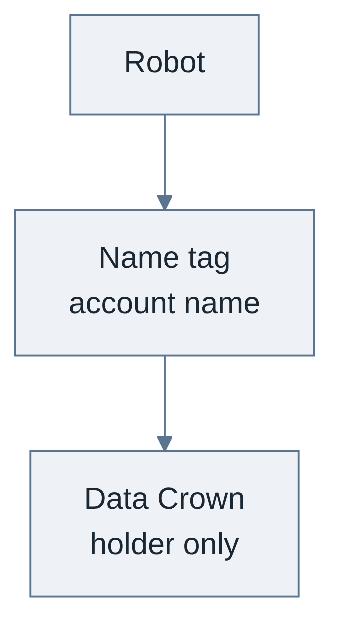
Order going up is robot, then name tag, then Crown. The holder's name tag dims slightly while the Crown is above it, so the Crown wins the eye. No per-case fixes and no dynamic repositioning.

Tuning
Parameter | Provisional | Range
spawn_asymmetry_ratio | 0.7 | 0.55 to 0.85. Lower is more asymmetric
min_spawn_distance | Tune to arena scale | —
crown_telegraph_duration | 3 s | 2 to 5
crown_orbit_height | Above the name tag | —

Edge cases
Case | Handling
Holder disconnects | The Crown drops at their last position and becomes free after a 1 s telegraph, so nobody takes it by accident. Their banked score stays on the standings as a disconnected entry
Holder is spun out | Keeps the Crown. Spin-out is a recovery state, not a dispossession — see FD-03
Crown ends up outside the arena | Cannot happen. The arena is closed, per FD-06
Crown spawns and nobody drives toward it | Not a rules problem — the telegraph is not readable enough. Treat as a feedback bug
Two robots touch the free Crown on the same tick | Authority resolves first touch. Ties break by lowest ParticipantRef, consistent with the foundation's contact ordering

Open decision
Minimap — not shipping. The arena is small and closed, the Crown's rim pass draws through geometry, and the off-screen arrow covers direction and distance. A minimap would be a third answer to a question already answered twice, on a screen whose scarcest resource is attention. Revisit only if the arena grows past what the rim pass can serve.

